Project Planning Phase
Project Planning Template (Product Backlog, Sprint Planning, Stories, Story points)

Date | 03 October 2026
Team ID | SWTID-2026-4339
Project Name | Streamlining IT Procurement: Automating Standard Laptop Orders with Flow Designer
Maximum Marks | 5 Marks

Product Backlog, Sprint Schedule, and Estimation (4 Marks)
Use the below template to create product backlog and sprint schedule
Sprint | Functional Requirement (Epic) | User Story Number | User Story / Task | Story Points | Priority | Team Members
Sprint-1 | Catalog Request | USN-1 | As an employee, I can open the Standard Laptop item in the service catalog. | 2 | High
Sprint-1 |  | USN-2 | As an employee, I can submit a laptop request by entering the model, quantity and business justification. | 3 | High
Sprint-1 |  | USN-3 | As an employee, I get an error if I leave a mandatory field empty or enter an invalid value. | 2 | High
Sprint-1 | Approval Workflow | USN-4 | As the system, I trigger the Flow Designer flow automatically when a request is submitted. | 5 | High
Sprint-1 |  | USN-5 | As a manager, I receive an approval request for my team member's laptop order. | 3 | High
Sprint-1 |  | USN-6 | As a manager, I can approve or reject a request and add a comment. | 5 | High
Sprint-2 | Procurement & Fulfilment | USN-7 | As the IT procurement team, I get a procurement task created automatically for every approved request. | 5 | High
Sprint-2 |  | USN-8 | As an IT team member, I can view and assign procurement tasks. | 3 | Medium
Sprint-2 |  | USN-9 | As an IT team member, I can mark the laptop as ordered or delivered and close the task. | 3 | High
Sprint-2 | Notifications | USN-10 | As a requester, I receive an email confirming my request was submitted. | 2 | Medium
Sprint-2 |  | USN-11 | As a requester, I am notified when my request is approved or rejected. | 3 | Medium
Sprint-2 |  | USN-12 | As a requester, I am notified when my laptop order is completed. | 2 | Medium
Sprint-2 |  | USN-13 | As a manager, I get a reminder if my approval is still pending. | 2 | Low
Sprint-3 | Standard Model Rules | USN-14 | As an employee, I can only select approved standard laptop models. | 3 | High
Sprint-3 |  | USN-15 | As the system, I automatically reject requests for non-standard models with an explanation. | 3 | Medium
Sprint-3 | Reporting | USN-16 | As an IT manager, I can see a dashboard of requests by status. | 5 | Medium
Sprint-3 |  | USN-17 | As an IT manager, I can view the average fulfilment time per laptop model. | 5 | Medium
Sprint-3 | Exception Handling | USN-18 | As an admin, I am alerted when a flow action fails so that I can fix it. | 4 | High
Sprint-4 | Testing & Release | USN-19 | As a tester, I can execute and document UAT test cases for the flow. | 5 | High
Sprint-4 |  | USN-20 | As a developer, I can fix defects found during UAT. | 5 | High
Sprint-4 |  | USN-21 | As a tester, I can run performance tests with concurrent and bulk requests. | 3 | Medium
Sprint-4 |  | USN-22 | As a developer, I can deploy the flow to production using an update set. | 4 | High
Sprint-4 |  | USN-23 | As a team, we prepare a user guide and handover documentation. | 3 | Low

Project Tracker, Velocity & Burndown Chart: (4 Marks)
Sprint | Total Story Points | Duration | Sprint Start Date | Sprint End Date (Planned) | Story Points Completed (as on Planned End Date) | Sprint Release Date (Actual)
Sprint-1 | 20 | 6 Days | 05 Oct 2026 | 10 Oct 2026
Sprint-2 | 20 | 6 Days | 12 Oct 2026 | 17 Oct 2026
Sprint-3 | 20 | 6 Days | 19 Oct 2026 | 24 Oct 2026
Sprint-4 | 20 | 6 Days | 26 Oct 2026 | 31 Oct 2026

Velocity:
Each sprint is 6 days long and the team's planned velocity is 20 (story points per sprint). The team's average velocity (AV) per iteration unit (story points per day) is the velocity divided by the sprint duration:
AV = velocity / sprint duration = 20 / 6 = 3.33 story points per day
Burndown Chart:
A burn down chart is a graphical representation of work left to do versus time. It is often used in agile software development methodologies such as Scrum. However, burn down charts can be applied to any project containing measurable progress over time. The chart below shows the planned (ideal) burndown for the 80 story points across the 4 sprints; actual progress will be added as each sprint is completed.
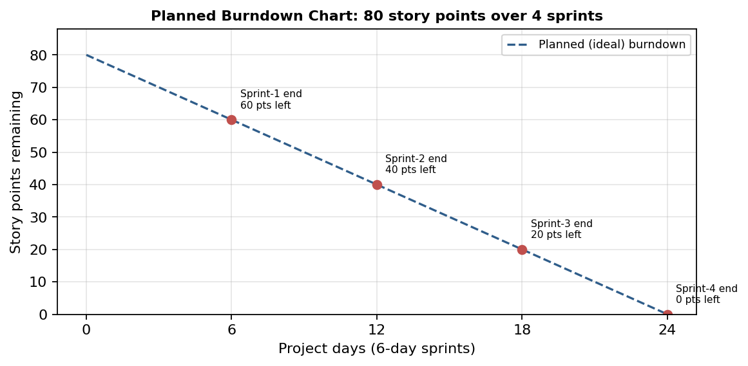
https://www.visual-paradigm.com/scrum/scrum-burndown-chart/
https://www.atlassian.com/agile/tutorials/burndown-charts

Reference:
https://www.atlassian.com/agile/project-management
https://www.atlassian.com/agile/tutorials/how-to-do-scrum-with-jira-software
https://www.atlassian.com/agile/tutorials/epics
https://www.atlassian.com/agile/tutorials/sprints
https://www.atlassian.com/agile/project-management/estimation
https://www.atlassian.com/agile/tutorials/burndown-charts

